

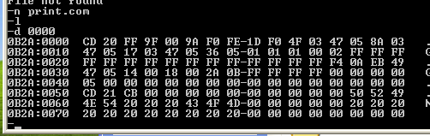

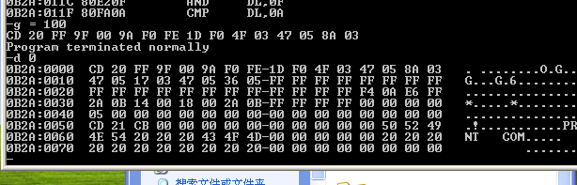

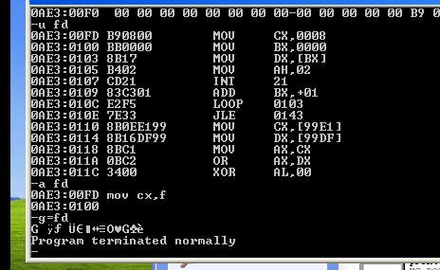

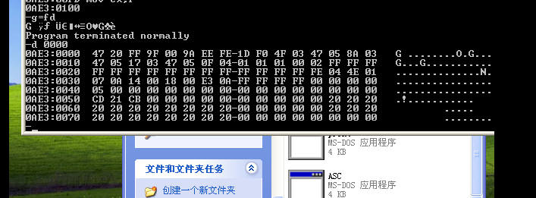

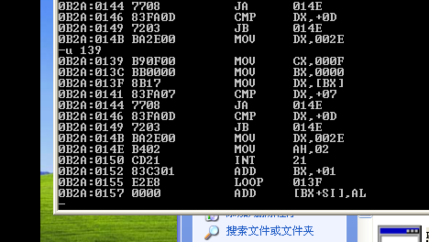

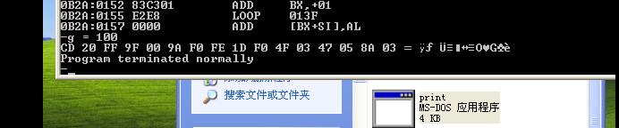

bufx db ?  
bufy db ?  
bufz db ?  
buff db 0  
data ends  
  
code segment  
start:  
mov ax,data  
mov ds,ax  
mov al,bufx  
  
cmp al,bufy  
jne next1  
add buff,1  
cmp al,bufz  
jne exit ;x=y!=z  
add buff,1  
jmp exit ;x=y=z  
  
next1:  
cmp al,bufz  
je next2  
mov al,bufy  
cmp al,bufz  
je next2  
jmp exit ;x!=y!=z且x!=z  
  
next2:  
add buff,1 ;x!=y=z或x=z!=y  
exit:  
mov [dl](https://www.baidu.com/s?wd=dl&tn=SE_PcZhidaonwhc_ngpagmjz&rsv_dl=gh_pc_zhidao" \t "_blank),buff  
add [dl](https://www.baidu.com/s?wd=dl&tn=SE_PcZhidaonwhc_ngpagmjz&rsv_dl=gh_pc_zhidao),30h  
mov ah,2  
int 21h  
mov ax,4c00h  
int 21h  
code ends  
end start